Free China: The Courage to Believe
(Synopsis – Documentary film)
“STIRRING … NARRATIVE POWER” New York Times, (June 6th, 2013)

Bound by a common conviction, the fates of a woman living in Beijing and a man living in New York become inextricably linked in a story of courage and freedom…

The award winning “Free China: The Courage To Believe” tells the true story of a mother and former Communist Party member, Jennifer Zeng, who along with more than 70 million Chinese were practicing a belief that combined Buddhism and Daoism until the Chinese government outlawed it. The Internet police intercepted an email and Jennifer was imprisoned for her faith. As she endured physical and mental torture, she had to decide: does she stand her ground and languish in jail, or does she recant her belief so she can tell her story to the world and be reunited with her family? A world away, Dr. Charles Lee, a Chinese American businessman, wanted to do his part to stop the persecution by attempting to broadcast uncensored information on state-controlled television. He was arrested in China and sentenced to three years of re-education in a prison camp where he endured forced labor, making amongst other things, Homer Simpson slippers sold at stores throughout the US.

With more than 100 thousand protests occurring each year inside China, unrest among Chinese people is building with the breaking of each political scandal. As China’s prisoners of conscience are subjected to forced labor and even organ harvesting, this timely documentary exposes profound issues such as genocide and unfair trade practices with the West. The film also highlights how new Internet technologies are helping bring freedom to more than 1.3 billion people living in China and other repressive regimes throughout the world. “Free China” is a co-production between NTD Television and World2Be Productions.

Screened at over 700 private venues around the world, including…
UK Parliament (July 1st, 2013) European Parliament, Brussels (Mar. 27, 2013)
Israeli Parliament (Apr. 24, 2103) London School of Economics (Mar. 20, 2013)
Google Headquarters, CA (Jan. 24th 2013) US Congress (Sep. 20, 2012)
American Philosophical Society, Philadelphia (May 16, 2012)
Theatrical Release to Date (US): Laemmle Music Hall, Beverly Hills, CA (May 31st – June 6th, 2013), Quad Cinema, New York, NY (June 7th – June 20th, 2013) and 10 city run through Landmark Theatres in the US on June 25th, 2013 (Atlanta, Boston, Chicago, Houston, Denver, Philadelphia, San Francisco, Seattle, Washington D.C and St. Louis.) Theatrical release PR: www.MurphyPR.com
CONTACT:
Kean Wong (Executive Producer/Producer): kean.wong@ntdtv.com Cell: +1 (347) 554-4940
Michael Perlman (Director/Writer/Producer): mperlman@world2be.com Cell: +1 (201) 926-3092
International Sales: info@catndocs.com www.CatnDocs.com

Interviewees in the film (see full bios below):
Jennifer Zeng, Former Communist Party Member, Best Selling Author
Dr. Charles Lee, American Chinese Businessman, Labor Camp Survivor
Hon. David Kilgour, Former Canadian Secretary of State (Asia-Pacific)
Rep. Chris Smith, US Congressman, Chair of Congressional-Executive Commission on China
Ethan Gutmann, Author of “Losing the New China” and Contributor for The Asian Wall Street Journal
Main Credits (Full Credit List at end of Media Kit)
Directed/Written/Produced by: Michael Perlman (World2Be Productions)
Producer/Executive Producer: Kean Wong (NTD Television)
Original Music: Tony Chen Video Editor(s): Jo Burgess & Tal Atzmon & Andrew Moody
Original Song Performed by: Q’orianka Kilcher (included in the theatrical release FreeChinaSong.com)
Photography/Cinematography: Tal Atzmon & Rumi Geiger Sound Mix: Carlos “Storm” Martinez
Other Details:
Run time: 53:30 (TV distribution version) and 61:07 (DVD/Theatrical Release version)
Original Format: HD 1920:1080 Screening Format: HDCAM/.mov/Bluray/DCP
Country of Production: USA (New York) Sound: Dolby Digital 5.1 Language: English
Completed: May 2013 TV release: TBA Language: English Subtitles: English & Chinese (+26 languages)
Online Digital Release: Nov. 15th, 2014 (English/Chinese only)
Main Photos/Images & Captions for Press Use: http://tinyurl.com/mdkqafm
Additional Photos/Images & Captions for Press Use: http://tinyurl.com/bspgdc6
Footage/B-roll from Film for Press Use: http://tinyurl.com/mhf7b7h

Awards/Nominations
- 86th Academy Oscar Contender for Best Documentary, Best Original Score and Song (2014)
- Best Documentary & Best Music Award at the Bangalore Short Film Festival, India (6.20.2014)
- International Winner – Feature Documentary at the 12th Annual GSFF, NJ ( April, 2014)
- Best Documentary at the 2014 NOIDA International Film Festival, India (Feb. 9th, 2014)
- Best Song for Indie Film/Documentary/Short at 2013 Hollywood Music in Media Awards
- Official Selection at 2013 CAM International Film Festival in Cairo, Egypt (Oct 2013)
- Best Program at Open Film Festival Travno, Zabreb, Croatia (July 2013)
- Official Selection at Millenium International Documentary Film Festival, Belgium (June, 2013)
- Best Feature Film at IX International Short Film Festival - FENACO (Peru, Nov 17th 2012)
- “Best of the Fest” at Freethought International Film Festival (Denver, August 3rd 2012)
- Winner at American Insight Free Speech Film Festival (Philadelphia May 16th 2012)
- Top Award in category (international political and cultural documentaries) at LA Awareness Film Festival (May 6th and Nov 4th in Venice, CA, 2012)
- Top Award (docs. under 60 min.) at 45th WorldFest Houston Int. Film Festival (April 21st 2012)
- Nominated: ‘Best Sound Track Album’ 2012 Hollywood Music in Media Awards
- Official Selection at the 15th East Lansing Film Festival in 2012 & 2012 LA Indie Film Festival
- Official Selection at the 17th Palm Beach International Film Festival in 2012
- Official Selection at the 2012 Ottawa International & Ottawa Free Thinking Film Festival

What people are saying about the film…
“STIRRING…NARRATIVE POWER”
David DeWITT, NY Times, June 6, 2013
"FREE CHINA puts two courageous and articulate faces to the crisis....with its aggressive narration, haunting music and disturbing photographic evidence of crimes against humanity, [FREE CHINA] wants you to walk away outraged at the injustice of it all, and most likely, you will."
Robin Migdol, Village Voice, June 7, 2013
“..brave, upsetting… deeply inspiring…the film is not only about highlighting China’s humanitarian offenses–it’s about rallying the West to push for the dissemination of free information to the Communist state.” Jacob Combs, Thompson on Hollywood, indieWIRE
June 7, 2013
“…will open some viewers' eyes to the horrifying reality behind many a "Made in China" label.”
Sheri Linden, LA Times, May 29, 2013
“…delivers a powerful, if at times heavy-handed, warning: The systematic and state-sanctioned persecution of peaceful citizens is alive and well in China.”
LA Weekly, May 29, 2013
“I hope this Film Changes Our World”
Margaret Chew Barringer, American Insight & Free Speech Film Festival founder
“Unbelievable Story….”
Scott Stanford, NBC New York Emmy Award Winning Anchor
“Intensely Compelling….”
Karen Curry, Former CNN New York Bureau Chief
“This Film will be a Game Changer”
US Congressman Chris Smith, Chairman of Congressional-Executive Commission on China
“Free China shows the way to a more democratic and peaceful regime …where everybody wins instead of the Communist Party” Professor Peter Navarro, Author and Director of “Death by China”
Reviews/Press - http://freechina.ntdtv.org/category/press/
Free China’s Jennifer Zeng TV interview with Scott Stanford on NBC New York (June 7th 2013)
http://freechina.ntdtv.org/free-chinas-jennifer-zeng-on-nbc-new-york-june-7-2013/

Free China: NY Times review – A Repressed Sect’s Ordeal, via Two Victims (June 6th 2013)
http://movies.nytimes.com/2013/06/07/movies/free-china-directed-by-michael-perlman.html?_r=1&
IndieWire Review: “Free China”: A Struggle for the Future of China’s Soul (June 7th, 2013)
http://blogs.indiewire.com/thompsononhollywood/free-china-a-struggle-for-the-future-of-chinas-soul

LA Times Movie Review: “Free China” Spotlights Falun Gong Followers Plight (May 31st 2013)
http://articles.latimes.com/2013/may/31/entertainment/la-et-mn-free-china-review-20130531
Free China: LA Weekly review (29th May 2013)
http://www.laweekly.com/movies/free-china-the-courage-to-believe-2086087/
‘Free China’ Movie Wins International Award (Free Speech Awards)
http://www.theepochtimes.com/n2/united-states/free-china-movie-wins-international-award-238990.html

"Free China" Film Wins Free Speech Award in Philadelphia
http://www.youtube.com/watch?v=S2zU_TuZJEE
Big Hollywood: ‘Free China’ Producer on Why the Communist Country Fought to Stop this Film
http://www.breitbart.com/Big-Hollywood/2012/10/26/bh-interview-free-china

Ottawa sun: Film Exposes Life and Death in China
http://www.ottawasun.com/2012/11/01/films-expose-life-and-death-in-china
Saigon Broadcasting TV Network – The Victorian To Uyen’s Show (interview in English)
http://www.youtube.com/watch?v=oBdpf-1a9WE&feature=share
Living 100% (30 minute interview with producer & director in English, Chinese subtitles)
http://www.ntdtv.com/xtr/b5/2013/02/02/a841552.html
Israeli Leaders Blast Chinese Regime's Organ Harvesting, Persecution (Free China mentioned)
http://www.thenewamerican.com/world-news/europe/item/15266-israeli-leaders-blast-chinese-regimes-organ-harvesting-persecution

BBC interviews David Kilgour (one of our 3 key expert witnesses) on Organ Harvesting in China
http://www.bbc.co.uk/programmes/p017k033
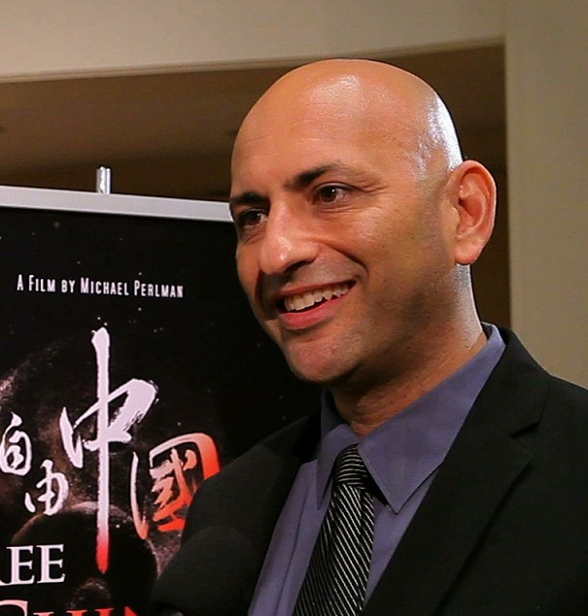
Michael Perlman: Writer/Director/Producer of Free China
Perlman is an award-winning filmmaker, performing artist, attorney and founder of two not-for-profit organizations.
He has traveled to over 60 countries and spoken to thousands of people at concert benefits, film screenings, schools and other venues on issues related to politics, human rights, activism, the law, media, conflict resolution, religion, spirituality and positive thinking.
Perlman works with human rights organizations in the US, Burma, China and the Sudan. He has been instrumental in providing critical materials to democracy advocates inside Burma that has helped foster freedom. Perlman has been selected by Amnesty International as an official Artist for Amnesty.
Perlman helped found and served on the board of Cross Cultural Solutions (CCS), one of the largest volunteer organizations in the United States. With a staff of over 200 and a special consultative status with the United Nations, CCS places more than 4,000 Americans in 10 countries to assist schools, hospitals, orphanages and agricultural programs that directly help more than 100,000 individuals annually.
Perlman is also the founder and director of Rock To Save Darfur, which has produced concert benefits that have helped thousands of lives and free hundreds of slaves with partners such as Save The Children and Doctors Without Borders.
Perlman produced, wrote and directed the New York Times Critics Choice film “Eyes of the World,” which Variety praised as “intense, passionate and intelligent.” This behind-the-frame look into war journalism reveals the physical and emotional price paid by photojournalists as they document human rights atrocities and the human capacity to endure. Photographs from the film were used to prosecute war criminals in The Hague.
Perlman produced, wrote and directed the award winning PBS International documentary “Tibet: Beyond Fear.” It has been translated into 12 languages and broadcasted on television worldwide. The New York Times hailed the film as “Emotional …. Riveting…. Compelling.” With an opening by Richard Gere, the film includes the Dalai Lama and the International Advocacy Director of Amnesty International. This documentary highlights Ngwang, a Buddhist nun, and Bagdro, a Buddhist monk, who at the ages of 13 and 20 led freedom protests in Tibet.
Perlman’s recently released film is the award-winning “Free China: The Courage To Believe.” On the heels of more than 400 private screenings, including for the US Congress, European Parliament, British Parliament, Amnesty International and Google Headquarters, the film has been released theatrically in 12 major US markets. The film examines the widespread human rights violations in China through the stories of Jennifer Zeng, a mother and former Communist Party member, and Dr. Charles Lee, a Chinese American businessman, who along with hundreds of thousands of peaceful citizens are tortured and subject to slave labor, producing products exported to department stores throughout the United States.

It also highlights new Internet technologies that are bypassing government censorship and allowing free information into closed societies.
The New York Times has praised the film as "stirring." Karen Curry, former CNN New York Bureau Chief, has described the film as “Intensely compelling" and indieWIRE has hailed the film as “deeply inspiring."
In August, Perlman will release the award -winning "The 99%: Occupy Everywhere." Narrated by Lou Reed, featuring Russell Simmons and Jeffrey Sachs, the film explores the voices of a diverse group of Americans who share the belief that money in politics has corrupted American democracy, affected legislation and transferred income from 99% of the population to multi-national corporations and the wealthiest Americans. Issues such as fair taxation, greater access to health and education, the environment, debt, job creation and gun safety are addressed and solutions are offered for a fairer and more sustainable future.
Perlman is also the founder and lead vocalist in the socially conscious band, Rejectionist Front. The single "Fifty Dollars" about freeing slaves in Africa, from the debut CD mixed by Grammy Winner Andy Wallace (Nirvana, Linkin Park, System Of The Down, Perfect Circle), played on radio nationwide. An upcoming CD "Evolve" will be released shortly. The band has had the honor of sharing the stage with many inspiring artists, including Talib Kweli, George Clinton & P-Funk, Joan Baez, Immortal Technique and the Nappy Roots. Rejectionist Front is proud to play in support of vital causes including Rock The Vote, Save Darfur, Wounded Warrior, the USO, Rock Against Dystrophy and Occupy Wall Street. Their single “Reclaim” is part of the Music For Occupy compilation along with many socially conscious artists including Crosby and Nash, Jackson Browne, Warren Haynes, Patti Smith, Third Eye Blind and Tom Morello. The music video "Flush," highlighting bank fraud that led to the worst economic crisis since the Great Depression, was featured on MTV Iggy as part of the Sounds of the Revolution.
Filmographies:
Eyes of the World - 2003
Tibet: Beyond Fear – 2008
Free China: The Courage to Believe - May 2013
The 99%: Occupy Everywhere – 2013 (to be released in August 2013)
Contact: mperlman@world2be.com
www.world2be.com

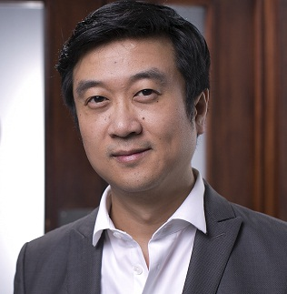
Kean Wong
Producer and Executive Producer of Free China
Kean is an award-winning filmmaker, activist, TV producer/host and founder of Parigon Partners, a strategy and marketing consulting firm specializing in new media and social entrepreneurship. With an eclectic mix of actuarial finance training and passion for personal development, Kean moved into the world of management consulting, where he worked for clients in a wide range of industries, including funds management, finance, real estate, fashion, software, biotechnology, health and wellness, as well as the TV infomercial industry.
Following his calling, he moved to New York where over the last 8 years he has been volunteering for New Tang Dynasty Television, a nonprofit TV network headquartered in New York City and pioneer of broadcasting uncensored programming into and out of China via satellite and the internet.
At NTD, Kean produced/hosted a variety of shows, including “The New Millionaire,” and was the lead male anchor for China News and Asia Brief from 2005-2011. Since 2010, he has been the main host of NTD’s International Chinese Culinary Competition in Times Square, dubbing himself a ‘Freedom Fighting Foodie.’ In 2006, Kean also hosted a show that won the New American Media award for the Best Investigative and In-Depth Program under the Broadcast section. The topic was on “Hi-tech Companies, the Chinese Government and the Internet.”
In 2001, he met Jennifer Zeng, one of the main subjects of the film and helped her apply for asylum in Australia. Years later, in New York, he met Michael Perlman and shared her incredible story with him, thus beginning the journey of ”Free China…”
On the heels of more than 400 private screenings, including for the US Congress, European Parliament, British Parliament, Amnesty International and Google Headquarters, “Free China” has been released theatrically in 12 major US markets (in May and June 2013). The New York Times has praised the film as "stirring." Karen Curry, former CNN New York Bureau Chief, has described the film as “Intensely compelling" and indieWIRE has hailed the film as "deeply inspiring."
As part of promotional efforts, Kean also orchestrated the recent release of the Free China theme song music video FreeChinaSong.com and the “A Year for Human Rights in China” open letter co-authored by Nobel Peace Prize Laureate Archbishop Desmond Tutu and blind dissident Chen Guangcheng. The statement was on the front page of The Huffington Post on June 4, 2013, and the accompanying petition can be found on www.TheCommunity.com and the film’s website.
Contact: kean.wong@ntdtv.com
Interviewees
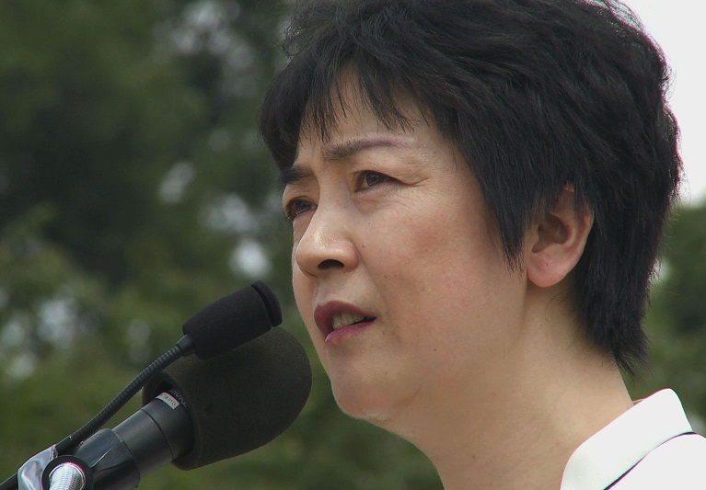
Jennifer Zeng
Jennifer Zeng is a mainland Chinese-born human rights activist, journalist and author, best known for her practice of Falun Gong, the subsequent government suppression of the movement, and the best-selling book she wrote about her experience regarding Falun Gong: “Witnessing History: One Chinese Woman's Fight for Freedom and Falun Gong.”
A mother and former Communist Party member, Jennifer was imprisoned for her faith. As she endured physical and mental torture, she had to decide: does she stand her ground and languish in jail, or does she recant her belief so she can tell her story to the world? Her compelling and inspiring personal story is the subject of the award-winning film “Free China: The Courage to Believe.”
Ms. Zeng has a Bachelor of Science in geochemistry and she went on to receive a Master of Science in geochemistry from Peking University. She now resides in New York.

Dr. Charles Lee
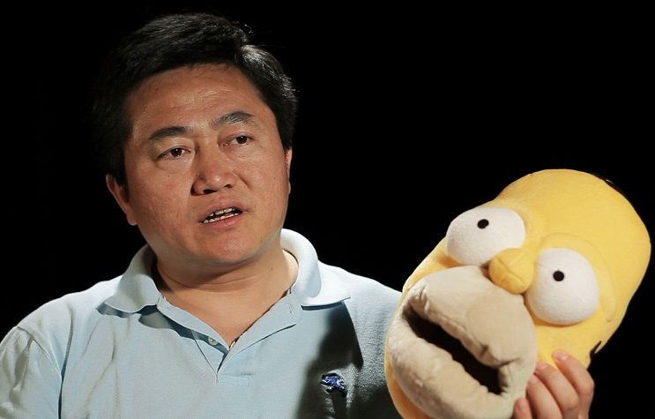
A medical doctor by training, Charles Lee currently serves as a spokesperson for the New York-based Global Center for Quitting the Chinese Communist Party. Born in China in 1965, he experienced the Cultural Revolution firsthand, then began medical studies at Sun Yatsen University of Medical Sciences, where he obtained a Bachelors in Medicine. Disillusioned with the CCP after the 1989 crackdown on the prodemocracy movement, he moved to the United States.
In America, Charles came across the Falun Gong spiritual discipline and began practicing wholeheartedly. In 1999, when the CCP began persecuting Falun Gong, Charles took particular note of the lies and slander being disseminated by the Party’s propaganda apparatus. He realized that to stop the persecution, it was essential to help Chinese people understand the truth about Falun Gong.
In 2002, Charles decided to do this by electronically tapping into the Party-controlled cable television system and broadcasting uncensored programming. He was arrested in October
2002, but managed to escape and return to the United States; however, having been unable to accomplish what he intended to do, he went back again in January 2003 and was captured again.

Despite the intense pressure to renounce his beliefs, Charles never cooperated with the prison guards. After his release from prison in January 2006, he returned to the United States. Since then, he has been traveling the world and actively working to expose the reality of the persecution and share what he personally witnessed and experienced, including severe torture and slave labor, making amongst other things, Homer Simpson slippers for export to the West. He has spoken at universities, been interviewed on television and recently featured in the award-winning film “Free China.” He currently lives in New Jersey with his wife and daughter.

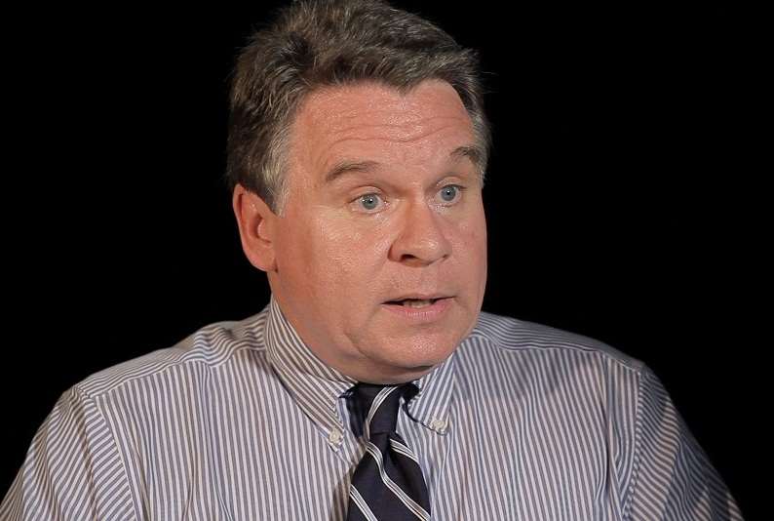
Congressman Chris Smith
Elected in 1980, Rep. Chris Smith (R-Robbinsville, NJ) is currently in his 17th term in the U.S. House of Representatives and serves residents in the Fourth Congressional District of New Jersey. Smith, 59, currently serves as a senior member on the Foreign Affairs Committee, and is chairman of its Africa, Global Health, Global Human Rights and International Organization Subcommittee.

In 2011-2012 he chaired both the Commission on Security and Cooperation in Europe (CSCE) and the Congressional-Executive Commission on China. He also serves as the “Special Representative” on Human Trafficking for the OSCE Parliamentary Assembly and as an executive member of the Tom Lantos Human Rights Commission. Previously, he served as Chairman of the Veterans Committee (two terms) and Chairman of the Foreign Affairs’ Subcommittee on Human Rights and International Operations and the Subcommittee on Africa.
A lifelong New Jerseyan, Congressman Smith graduated from the College of New Jersey with a degree in business administration. Prior to being elected to Congress, he helped run a small business—his family's wholesale sporting goods corporation. He is also the former Executive Director of the New Jersey Right to Life Committee.

The congressman is married to his wife of 35 years, Marie, and they have four grown children.

Hon. David Kilgour
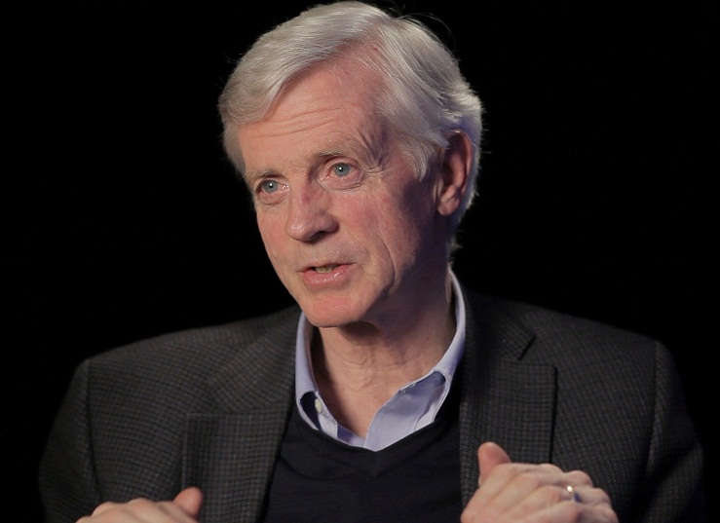
David Kilgour is co-chair of the Canadian Friends of a Democratic Iran, past chair of the Latin America and Caribbean policy working group of the Ottawa branch of the Canadian International Council, a director of the Washington-based Council for a Community of Democracies (CCD), a Fellow of the Queen's University Centre for the Study of Democracy, a director of the New York-based NGO Advancing Human Rights and a director of the Ottawa Mission Foundation.

First elected to the House of Commons in 1979, he was re-elected seven times, most recently in 2004, for the south-east region of Edmonton. During his time in Parliament, he was Deputy Speaker and Chair of the Committees of the Whole House, Secretary of State for Latin America & Africa (1997-2002) and Secretary of State for Asia-Pacific (2002-2003). He did not stand in the 2006 election.

David remains active on issues of human dignity. A 2007 book, “Uneasy Neighbo(u)rs,” co-authored with David Jones, a former American diplomat, discusses the relationship of Canada and the USA. In 2009, he published with David Matas “Bloody Harvest: The Killing of Falun Gong for their Organs.” He and Matas were awarded the 2009 Human Rights Prize of the International Society for Human Rights in Switzerland for their work in raising awareness of state-sponsored organ pillaging in China. In 2010, he was been nominated for the Nobel Peace Prize for his work related to the investigation of organ harvesting crimes against Falun Gong practitioners in China.
David is married to his wife of 39 years, Laura, and they have four grown children.
For further information, see: www.david-kilgour.com.

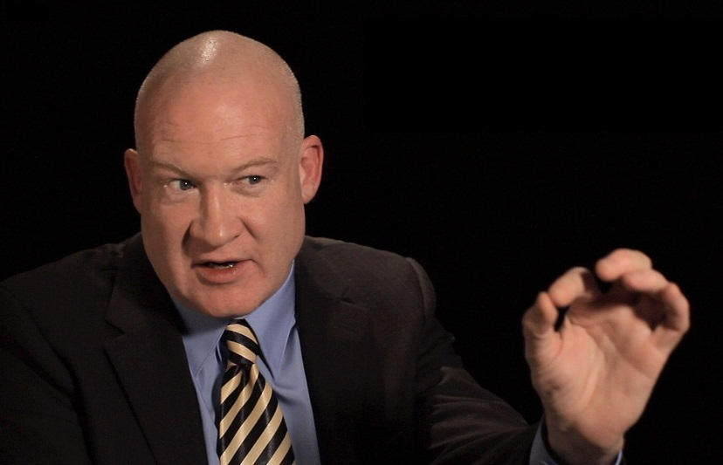
Ethan Gutmann
Foundation for Defense of Democracies, DC
Characterized as a "mammoth sociological, political whistleblower" by National Review, Ethan Gutmann is the author of “Losing the New China: A Story of American Commerce, Desire and Betrayal.”

Following Encounter Books’ first printing in 2004 and subsequent translation into Chinese by Taiwan-based Broad Press, Gutmann's book garnered several awards, including the "Spirit of Tiananmen," New York Sun's "Best Book of the Year," and the "Chan's Journalism Award" for outstanding writing. At the government and intelligence level, Gutmann's seminal research into Chinese Internet surveillance, the laogai system, and the intersection of Western business with Chinese security objectives has received sustained attention in Washington DC, London and Brussels.
Formerly a Senior Counselor at APCO China and a Visiting Fellow at Project for the New American Century, Ethan Gutmann has also written widely on Chinese military development, human rights, the US business scene in Beijing and the recent hacking phenomenon for The Asian Wall Street Journal, Investor's Business Daily, The Weekly Standard, National Review, World Affairs Journal, and other publications.
In the 1990s, Ethan Gutmann served as Chief Investigator for the AV network, directing "American Investigator," a documentary series. In the 1980s, Gutmann specialized in arms control and dynamic modeling as a foreign policy analyst at the Brookings Institution. Gutmann completed both a B.A. and a Master of International Affairs at Columbia University.
Assisted by research funding from the Earhart Foundation and the Peder Wallenberg family, Ethan Gutmann is currently completing a comprehensive history of the clash between Falun Gong and the Chinese state. In addition, with a travel grant awarded from the National Endowment for Democracy, Gutmann is currently researching the Chinese-Uyghur conflict, and the underlying ambiguity of the Chinese Communist Party's stance towards the Islamist global challenge.
Tony Chen - Composer
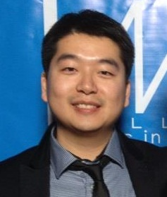
Tony Chen is an award-winning music composer/producer and voice over artist, who was recently nominated for the Best Soundtrack Album at the 2012 Hollywood Music in Media Awards™. The album was for the Award-Winning Documentary “Free China,” co-produced by New Tang Dynasty Television and World2Be Productions.
Originally from Beijing, China, Tony graduated from the music department at the University of Huddersfield in the UK where he studied music composition, scoring for film/TV/ Multimedia, vocal training, conducting and opera performance.
With a distinctive traditional Chinese flair, Tony’s music transcends cultures and time, crossing over ‘pop, classical Chinese and Western, and new age’ styles. Inspiring millions around the world, his compositions have been described as a fusion of Tan Dun (“Crouching Tiger, Hidden Dragon”) and Yanni’s music.

Tony also produces and hosts 2 popular radio shows ‘Morning Concert’ and ‘SOH Weekend Music FM’ of Sound of Hope Radio Station—the No. 1 Chinese radio program on Universal FM92.3 KSJO covering the entire San Francisco Bay Area and a half million Chinese people.

For more on Tony’s work, please visit: www.TonyChenMusic.com

‘The Courage to Believe” Free China theme song
(Song incorporated into the theatrical version of the film to be released in May/June 2013)
Music by Tony Chen Lyrics: Kean Wong & Michael Perlman
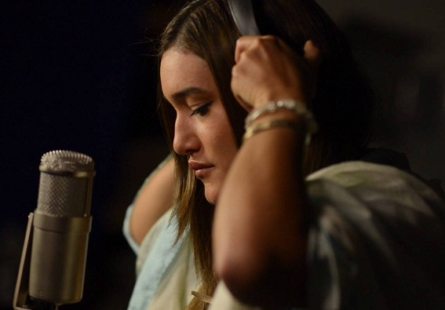
Performed by Q’orianka Kilcher
At the age of 14, Q’orianka Kilcher emerged into the front ranks of young actors with her portrayal of Pocahontas opposite Colin Farrell and Christian Bale in Terrence Malick’s Oscar nominated film “The New World."
Her performance won her the National Board of Review’s Best Breakthrough Performance of 2006 and the 2006 Alma Award for best Latin American Actress in a Feature Film, as well as numerous nominations and rave reviews.

Some of her other credits include Princess Kaiulani, the award-winning FX TV show Sons of Anarchy, Shouting Secrets, Hallmark Hall of Fames “Firelight,” the Syfy mini-series Neverland, The Killing, Longmire and The Power Of Few, starring Christopher Walken and Christian Slater, a film she not only starred in but also produced via her production company iQ Films. iQ Films’ upcoming slate of projects currently include “The Life,” a TV pilot shining light on the epidemic of child sex trafficking in the US, and the environmental SyFy feature “The Blueprint.”

As a young producer willing to see opportunity where others see risk, Q’orianka proved to be not only a young voice for change with a desire to break down some of the barriers of conventional filmmaking, but also someone with a vision for a more inclusive, interactive and collaborative filmmaking process and production model. Her contributions as a producer to films’ significant interactive and collaborative elements through participatory storytelling not only proved that there is opportunity where most see risk, but also was a major step in creating a new connection between Hollywood and a young passionate global audience—an audience with a desire to creatively express themselves and have their voices heard while exploring the new frontiers of today's interactive media and technology.

Q’orianka is not only an award-winning actress with high critical acclaim, but also an accomplished Singer/Songwriter and committed Human Rights and environmental activist. A fearless young force, shehas courageously and tirelessly used her public voice and privilege of celebrity to speak out for the voiceless and many of today’s most important and relevant causes and issues.
Her work in support of basic Human Rights, Social and Environmental Justice, corporate accountability and Indigenous peoples rights has not only garnered her many national and international nominations, awards and honors, including the Young Hollywood Green Award, the Gandhi Award and the prestigious Brower Youth Award , but has also won her the respect of many indigenous leaders and notable personalities like Nobel Peace Prize winner Rigoberta Menchu , Bolivian President Evo Morales, and Indigenous leader Alberto Pizango among others.

Her work and persona were one of James Cameron’s first inspirations in creating the character of "Naitiri " for the highly successful film "Avatar."
While Q’orianka frequently lends her celebrity, voice and energy as spokesperson and youth ambassador to many notable organizations such as Amnesty international, Green Peace, AIDESEP, IFG and Amazon Watch, just to name a few, her true passion is to help empower small grassroots community projects and indigenous youth initiatives from around the world and work directly with the many unsung everyday action heroes who she feels are the true front line soldiers of effective change.
Q’orianka is the founder of on-Q Initiative, Youth4Truth media and Action Hero Network with AHN being the first open source activist platform focused on empowering the many everyday action heroes within our communities and globally, while facilitating a more interactive, direct and collaborative approach to philanthropy itself.
Q'orianka frequently speaks at international conferences and panels including The United Nations - Declaration on the Rights of Indigenous Peoples, the International Forum on Globalization, Amnesty International’s women’s rights, World People's Conference on Climate Change and the Rights of Mother Earth, Rise-Up Woman’s Health Initiative and at various universities, including George Washington University and the Harvard Leadership conference, speaking on a wide spectrum of subjects including Human Rights, environmental and social justice, sustainability, indigenous peoples rights, corporate accountability, Free Trade, youth leadership, Juvenile justice, women’s rights and empowerment.
In her free time, Q’orianka enjoys dedicating herself to her passion for music and is hoping to play more live shows and record a CD of her original music.

ABOUT NTD (co-producers of “Free China”)

New Tang Dynasty (NTD) Television was founded in 2001 by a group of Chinese Americans. Recognizing a dangerous predicament for China and the West that is caused by Beijing’s severe media censorship, these individuals had a bold vision to break through China’s state media control and bring truthful and uncensored information to the Chinese people.

In 2004, NTD opened the first independent, uncensored satellite window into China, broadcasting uncensored programming 24/7 in Chinese language directly into parts of China. A second platform followed soon afterwards, in the form of a peer-to-peer (P2P) streaming video service that breaks through the Great Firewall of China. Running on the iPPOTV software, China Internet Channel enables even the least tech-savvy users to access NTD contents. In fact, NTD and its partner, the Global Internet Freedom Consortium, jointly operate the world’s largest Internet anti-censorship platform. Millions of Chinese scale the Great Firewall daily through this platform to access the real, uncensored Internet.

NTD was the first Chinese TV station to cover the SARS epidemic in 2003, breaking the story fully three weeks before Chinese officials acknowledged the outbreak. When thousands of children fell ill because of melamine-tainted milk in 2008, China’s state-run media covered up the news; NTD sounded the alarm to the Chinese people. Many NTD programs give voice to Chinese citizens to address their grievances about social injustice, human rights abuses and the persecution of Christians, Tibetans, Falun Gong, and rights activists. After a power struggle within the Communist Party broke out in early 2012, the daily Internet traffic from Mainland China to NTD’s site has soared 500 percent.

NTD acts as a watchdog on the authoritarian regime, bringing out the stories that no other TV stations dare to report.
www.NTDTV.org

SUPPORT FOR NTD
“I am a peasant in China. I’ve been saving my money by living frugally so that I can have money to buy a satellite dish… I have just bought a dish to watch NTD secretly with the people in my village, to let more people in my village know more about the truth outside [China].”
—Deng Hangcheng, viewer in Guangdong Province

“I appreciated very much the [NTD] interview with the [US] Deputy Assistant Secretary of State expressing his concern over Article 23… Thank you so much. The interview made a big impression in Hong Kong.”
– A Reporter at Apple Daily, Hong Kong

“[NTD’s] programmes are very different from the content on China’s state TV stations. There is a great deal of coverage of human rights issues, including the repression in Tibet and of religious groups such as Falun Gong and the underground Christian churches.”
—Reporters Without Borders

“This country has become thoroughly corrupt. They (the government) make up lies to cover up the crimes, and we have nowhere to tell our story; we have no protection for our basic rights. I thank NTD Television for your hard work; you give us a platform to speak, a right to our voice, listen to our experiences, and let the world know about our situation.”
— Peng Zhonglin, an interviewee for People’s Forum

“I want to thank NTD for reporting on my story. It helped speed up my release when I was being wrongfully held in police detention.”
—Sun Yukun, Rights Activist, Shanghai

“New Tang Dynasty TV was founded in 2001 and has gained an international reputation for its objective and timely reporting of political, economic, and cultural stories in Chinese.”
—International Federation of Journalists

“The pioneering US-based channel, New Tang Dynasty TV, is the only truly independent Chinese-language TV reaching tens of millions of private satellite dishes across China.”
—93 Members of U.S. Congress, Letter to President Bush, April 12, 2005

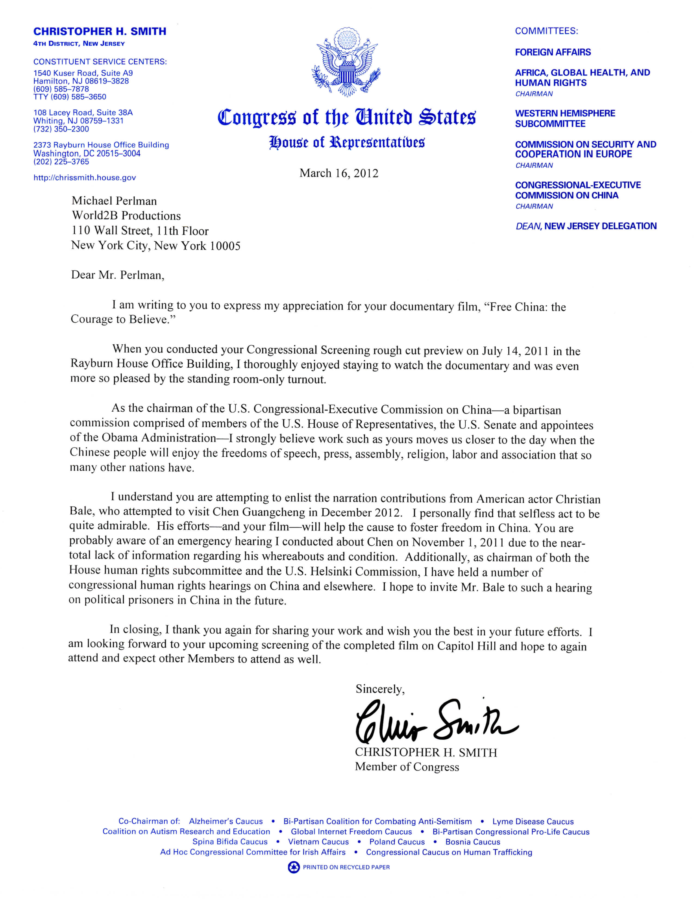

‘Free China’ Movie Wins International Award
By Pamela Tsai
Epoch Times StaffCreated: May 17, 2012Last Updated: August 21, 2012
Original Source: http://www.theepochtimes.com/n2/united-states/free-china-movie-wins-international-award-238990.html
Related articles: United States » National News

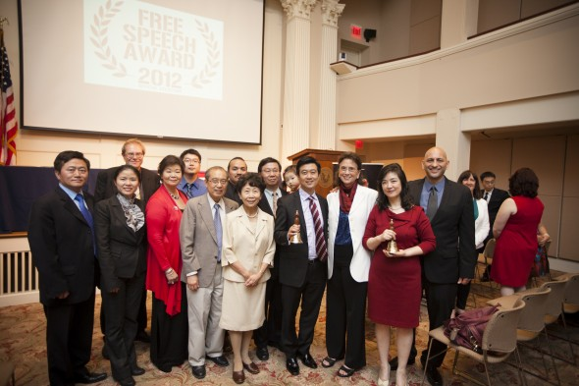
GROUP PHOTO: (R to L) Film director Michael Perlman, Jennifer Zeng, Margaret Chew Barringer, Kean Wong, producer; NTD President Zhong Lee, Kean Wong's parents. Left—Charles Lee (Edward Dai/The Epoch Times)
PHILADELPHIA—A documentary portraying how two Falun Gong practitioners stood up against the Chinese regime at great personal cost won yet another top prize at a film festival on Wednesday.
Free China: The Courage to Believe, took away top honors at the inaugural International Free Speech Film Festival in Philadelphia. Earlier it won the top award in its category at the Awareness Film Festival in West Hollywood on May 6 and another top award at the 45th World-Fest Houston Film Festival on April 23.
The practitioners’ personal stories are told against the backdrop of the 13-year-long persecution faced by more than 100 million Chinese people. Audience members at Wednesday’s event said they had heard and read about Falun Gong but had no idea of the magnitude of the persecution and had never been brought so close to it.

At the end of the day, it is not politicians, or governments, but the choices of every single one of us that will shape and create our own future.
—Jennifer Zeng in “Free China”
“I hope this film changes our world,” said Margaret Chew Barringer, a poet and filmmaker. The film festival is the latest initiative from American Insight, a nonprofit organization dedicated to promoting free speech founded by Barringer. “Free China” was screened to a full house in the Benjamin Franklin Hall.
“I was struck by the human scope of it,” Sharon Eisenhour said of the film. Eisenhour is a professor at Temple University’s School of Communication. “A lot of people in this country have no idea to what extent the persecution is,” she said.

Wouldn’t it be wonderful to have parks filled throughout this country of people doing Falun Gong, paying tribute to the film, to the story, to those who are being persecuted?
—Jennifer Lynn, American broadcast producer
The award ceremony was preceded by a panel of high-profile speakers including Karen Curry, former CNN bureau chief and veteran producer of broadcast news and CNN’s New York bureau chief. Also on the panel was Anne-Marie Slaughter, a professor of Politics and International Affairs at Princeton University who has served as director of Policy Planning for the United States Department of State.
Pulitzer Prize-winning poet, C.K. Williams; Reggie Shuford, senior counsel at the American Civil Liberties Union Foundation; Vernon Odom, host of the Channel 6 TV station’s weekly public affairs program; and Bob Craig, host of Big Band Jazz with Bob Craig, also spoke.
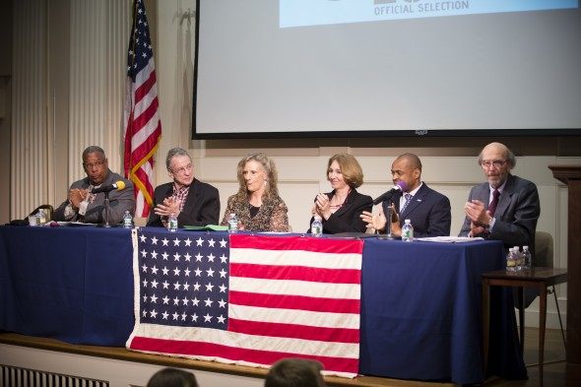
CELEBRITY PANELISTS: Vernon Odom, C.K. Williams, Karen Curry, Anne-Marie Slaughter, Reggie Shuford, Bob Craig (Edward Dai/The Epoch Times)

Lydia Hunn, professor at Drexel University’s College of Media Arts and Design, said she was moved to tears by the story of Jennifer Zeng, the Chinese woman profiled in the film. “I didn’t know the extent of this. I didn’t know there is so much repression,” she said.
Zeng was a former Chinese Communist Party member who belonged to China’s upper middle class and then became a prisoner of conscience in China and a human rights activist in exile. In telling her story, the film examines the journey to freedom taken by millions of Chinese citizens who have chosen to speak up against injustice in China.
Zeng, who was granted political asylum by Australia and now lives in the United States, is the author of the bestselling book, Witnessing History: One woman’s fight for freedom and Falun Gong.
“It was heart wrenching,” professor Hunn said. “She was so honest in her description of the pains of having to lie about giving up in her belief in order to get out and tell her story—a torture to her.”
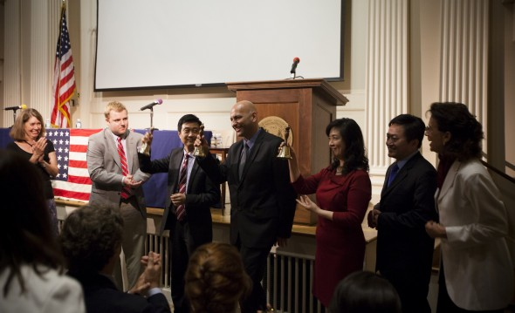
RINGING THE LIBERTY BELL: (3rd L) Kean Wong (producer), Michael Perlman (director), Jennifer Zeng, Charles Lee, Margaret Chew Barringer (Edward Dai/The Epoch Times)
Zeng, who was visibly touched while giving a speech at the award ceremony, said, “For me, free speech means two things: whether one has a kind enough heart to see the truth; and secondly, whether one has the wisdom and courage to search for the truth, or to simply accept it when it is presented.”
Zeng said the 13-yearlong sacrifice and suffering endured by millions of Falun Gong practitioners in China has become the most crucial test for people’s conscience and ability to take a stand between good and evil and right and wrong.
“At the end of the day, it is not politicians, or governments, but the choices of every single one of us that will shape and create our own future,” she said.
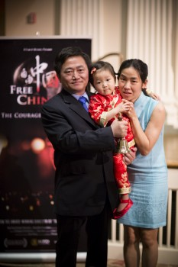
Charles Lee with wife and daughter (Edward Dai/The Epoch Times)
Alongside Zeng, U.S. citizen Charles Lee is profiled in the film. Lee is a former Harvard Medical School fellow who was imprisoned in a Chinese labor camp for three years for attempting to publicize the persecution of Falun Gong in China by tapping into the state-controlled television.
Lee suffered the same inhuman treatment as Zeng did: mental and physical torture, brainwashing, forced-feedings, forced labor, and the threat of becoming a victim of forced organ harvesting.
Both Lee and Zeng discussed their Chinese labor camp experiences of making toys and other consumer products sold in the United States by American companies. The film also examined the role of leading Western technology companies in the development of the Chinese regime’s internet censorship to suppress free speech.
Jennifer Lynn, a broadcast producer in Philadelphia, said she was “wowed by the power of the story.” Lynn, the Morning Edition host of NPR affiliate WHYY/91FM in Philadelphia said, “The story is of courage and truth. Really resounding. All I want to do now is to share it with more people.”
“Wouldn’t it be wonderful to have parks filled throughout this country of people doing Falun Gong, paying tribute to the film, to the story, to those who are being persecuted?” Lynn said.
In the speech given at the award ceremony, Lee, who was accompanied by his wife and 2-year-old daughter, thanked the American people for their role in trying to end the injustice in China. He said the persecution of Falun Gong has reached far beyond the 100 million Falun Gong practitioners directly affected.
“Internationally, it also affects countries that have trading, diplomatic, political, and cultural relations with China,” he said. “The persecution is also directly against the universal principles of truthfulness, compassion, forbearance. The test is the toughest one for people of conscience, because they know that Falun Gong practitioners are good people and the persecution is unlawful and inhumane. If they want to continue to do business with the communist regime, they think they have to turn a blind eye to the persecution.”
Lee continued, “I believe it is the responsibility of each of us to uphold the moral standards that are the foundations of any society. A China without the Communist Party will be a truly free China and a stable friend to all countries around the world.”
Free China was selected from a group of six finalists that explored topics of censorship, resistance, inequality, courage, change, and hope. A panel of 50 judges from all walks of life chose the winner.
The film will be distributed free of charge to high schools globally.
Free China was directed by Michael Perlman, award-winning director of Tibet-Beyond Fear, and produced by Kean Wong, a Chinese-Australian filmmaker, TV producer, and host for New Tang Dynasty Television.
“With the persecution of truth, compassion, and tolerance you eradicate morality and principles that are the basis of a civil society, a free society, a prosperous society,” Wong said at the awards evening.
“I think that is why the Falun Gong issue is so critical, because if truth, compassion, tolerance and other beautiful spiritual practices out there are allowed to spread, then the morality of the entire nation can revive itself. And then naturally the government will not have to worry about stability,” Wong continued. “If individuals and families are given the freedom to live a moral life so that the society they are a part of is one that embraces and cherishes moral values, that is what China needs.”
Perlman said he directed the film in the hope that it would foster real freedom inside China. “And to let the Chinese government know they have nothing to be afraid of by allowing freedom in China. Because this is the way that China will become even stronger economically and politically.”
“History is on the side of freedom around the world,” he continued. “And it’s something that all of us together, both in the United States, and around the world, individually and collectively, can work and make it happen.”
The Epoch Times publishes in 35 countries and in 19 languages.
www.TheEpochTimes.com
Original Source:
http://www.theepochtimes.com/n2/united-states/free-china-movie-wins-international-award-238990.html
Or visit http://tinyurl.com/774vead

Full Credits
Written and Directed by
Michael Perlman

Produced by
Kean Wong
Michael Perlman

Executive Producer
Kean Wong

Edited by
Jo Burgess
Tal Atzmon

Co-Editor
Andrew Moody

Original Music
Tony Chen

Original Song
“The Courage to Believe”
Music by
Tony Chen
Lyrics by
Kean Wong
Michael Perlman

Performed by
Q’orianka Kilcher

Interviewees
Jennifer Zeng
Dr. Charles Lee
Congressman Chris Smith
Ethan Gutmann
Hon. David Kilgour

Narration By
Michael Perlman

Voice of CCTV Anchors
Tony Chen
Teresa Tan

Voice of China Administrator of Sports
Kean Wong

Camera
Rumi Geiger
Tal Atzmon

Lighting
Rumi Geiger

Location Recordist
Dafydd Cooksey

Color Correction
Tal Atzmon
Xin Qin

All audio post services by CreativeMixing.com

Supervising sound editor
Carlos “Storm” Martinez

Re-recording mixer
Carlos “Storm” Martinez

Additional sound design
Dafydd Cooksey
Fabio Emma
Yun Shiang Jian

Co-Production Manager
Kevin Koo

Website
Yan Peng
Benjamin Trenerry

Narration Script
Michael Perlman
Kean Wong

Narration Recording
Dafydd Cooksey
Fabio Emma

Translators
Alex Wu
Lan Qing
Jennifer Zeng
Dr. Charles Lee
Ann Chen
Andrew Chen

Subtitles
Lan Qing
Katharina Kraus
Claire Young
Hilary Lin
Lina Camarena

Archive Footage
NTD Television
World2Be Productions
Shen Yun Performing Arts

Archive Research
Jo Burgess
Lia Onely
Oliver Trey

Graphics
Jean Lem
Jens Almroth
Benjamin Trenerry
Andrew Moody
Tane Dalzell

Chinese Calligraphist
Jun Li

Animation Design
Boman Wang
Quentin Bellow
Original Song
"Free China: The Courage to Believe"
Music by Tony Chen
Lyrics by Kean Wong & Michael Perlman
Performed by Q’orianka Kilcher
Produced by Kean Wong, Tony Chen & Michael Perlman
Executive Producer: Kean Wong
Engineered & Mixed by Kevin Dippold & Tony Chen
Mastered by Paul DuGre
Additional Mixing by Tyler W. Thurmond & Olli Törmä
Additional Recording by Dave “Rainman” Banta of Platinum-Mixes.com
Music Video Edited by: Andrew Moody
Camera: Camera: Keith Yuan, Stanley Chen, Robert Hanson, Yi-Yuan Chang

Additional Music
‘Pudu’ from FalunDafa.org

PR Consultants
John Murphy and Russell Posternak from www.Murphypr.com
Mary Wald of www.MaryWald.com
Anne Borin
Jordan Moore

©2013 NTD Television, World2Be Production & Parigon Partners Int’l Inc.

All Rights Reserved

